Dundee Fire Department
179 Main Street, Dundee, Michigan 48131
Telephone: 734-529-2650 Fax: 734-529-5909
BURN PERMIT APPLICATION

DATE OF EVENT: TIME OF EVENT:

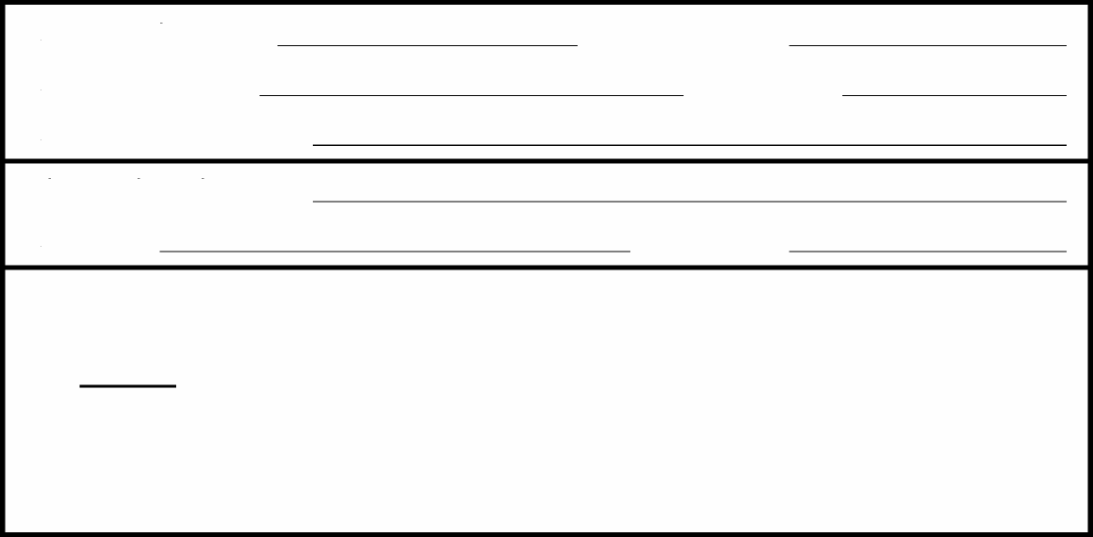

PERMISSION TO BURN CERTAIN RUBBISH, TRASH, LIMBS, LEAVES, GRASS, LUMBER OR OTHER COMBUSTIBLE MATERIALS WITHIN THE TOWNSHIP OF DUNDEE. A FIFTY (50) FEET MINIMUM DISTANCE IS REQUIRED FROM ANY STRUCTURE.

LIMITATIONS AS LISTED BELOW SHALL BE BINDING SUCH AS, BUT NOT LIMITED TO:
WIND SPEED, WIND DIRECTION, HUMIDITY, SIZE OF FIRE AND DURATION
APPLICATION DATE: PERMIT NUMBER:
APPLICANT NAME: TELEPHONE:
APPLICANT'S ADDRESS:
ADDRESS: TELEPHONE:
OWNER OF PROPERTY:
LOCATION OF EVENT: ______________________________________________________

TYPE OF MATERIAL TO BE BURNED:
LIMITATIONS (to be completed by Fire Chief):

**THIS PERMIT IS VALID FOR THE ABOVE DATE AND TIME ONLY.**
APPLICANT HEREBY AGREES TO ACCEPT FULL RESPONSIBILITY FOR ANY DAMAGE OR LOSS. IF ANY, RESULTING FROM THE BURNING OF THE ABOVE MATERIAL. IT IS HEREBY FURTHER AGREED BY THE APPLICANT THAT THIS FIRE SHALL NOT BE LEFT UNATTENDED AT ANY TIME, AND WILL BE SUPERVISED BY ME OR MY AUTHORIZED REPRESENTATIVE UNTIL THE FIRE IS COMPLETELY EXTINGUISHED. AT ANY TIME WHILE THE ABOVE MENTIONED MATERIALS ARE BEING BURNED, THE FIRE DEPARTMENT RECEIVES ANY TYPE OF COMPLAINT REGARDING THE BURNING, THE FIRE WILL BE EXTINGUISHED IMMEDIATELY.

APPROVED BY: SIGNED BY:
FIRE CHIEF  (or representative) |  | APPLICANT

BURN PERMITS
- All burn permits must be approved by the Fire Chief.
- Construction contractors needing to burn debris must obtain a Burn Permit Application from the Fire Department.
- After burn permit application has been submitted and approved, burning is still dependent upon visual inspection of burn site and weather conditions.
- No burning is allowed if the wind speed exceeds 10 mph.
- Only natural combustible materials are allowed.
- No flammable or combustible liquids allowed.
- Burn site will be manned at all times.
- Burning hours: 8:00 a.m. – 9:00 p.m., unless specified on Burn Permit. No burning between 9:00 p.m. and 8:00 a.m.

Dundee Township Fire Department 179 Main Street Dundee, Michigan 48131 Phone: 734-529-2650 Fax: 734-529-5909

